How To Guide - Editing the Login and Welcome Pages
There are two pages of the system that everyone will visit every time they use the application.
- The "Login Page" is the first page seen and it contains the login form.
- The "Welcome Page" is the page that is seen after people login.
Editing Pages:
- Go to the "CONFIG" tab => click "Manage Page Content".

- Click the "pencil" icon beside the page you wish to edit.
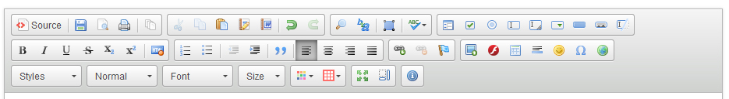
- Type the page content in the large editor box below. The editor provides a number of formatting buttons:
- "Paste" text, set text to "Bold" or "Italics", to chage the color of the text and the font face or size.
- The colored square button will allow you to upload images to the server. Click this button, then click "Browse Server" and then click "Upload" to copy an image from your computer to the server. Once the file has been uploaded you can click on it and insert it into your page.
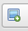
  - Position the cursor where you want the image to be inserted.
  - Click on the "Image Icon".
  - Click "Browse Server".
  - If the image is there, click on it and the click "Select".

  - If the image must be uploaded, click the "+" at the top to search
your computer for the image.
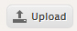
  - Once you have found and selected the image click the "Upload"
button to upload the image to the web server.
  - When the file is uploaded you can then select it for use in the web page.

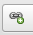
- The chain button will allow you to create a link on the page. Highlight the text or image
for the link, click this button and type the web address into the form.

  - If you wish to link to a document that you have uploaded, you need to go to the "Document Administration" and right click on the "View Document" icon and copy the link location. This location is the link to view the document.
  - Paste this link into the editor as the web address for your link.
- When you have finished editing the message click "Submit This Content" to save the page. It will now be available for users.

