How To Guide - Creating Additional Pages
It is possible to create additional HTML pages in the application so that users can view mode information about your organization, policies, or any other information you need to share.
Creating Additional Pages:
- Go to the "CONFIG" tab => "Additional Pages".
- Click "Insert New" to create a new page.
- Enter the "Page Name" as this is displayed in the menu for users.
- Create the page content...

Grouping Additional Pages:
Additional Pages can be grouped into categories and the page groups can be displayed as menu tabs on the parent and staff menus or they will be displayed as a drop-down menu under the "HOME" menu tab.
- Go to the "CONFIG" tab => "Content Menu Tabs"
- Enter the "Group Title".
- Sort the groups by dragging and dropping the entries.
- To have the groups displayed as menu tabs edit the "Application Profile" and set the field "Implement Additional Page Tabs" to "Yes"

Editing Additional Pages:
- Go to "CONFIG" => "Additional Pages".
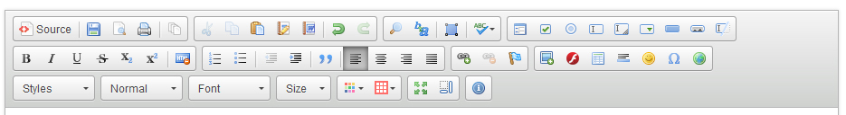

- Click the "pencil" icon beside the page you wish to edit.
- Type the page content in the large editor box below. The editor provides a number of formatting buttons:
- "Paste" text, set text to "Bold" or "Italics", to chage the color of the text and the font face or size.
- The colored square button will allow you to upload images to the server. Click this button, then click "Browse Server" and then click "Upload" to copy an image from your computer to the server. Once the file has been uploaded you can click on it and insert it into your page.
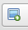
  - Position the cursor where you want the image to be inserted
  - Click on the "Image Icon"
  - Click "Browse Server"

  - If the image is there click on it and the click "Select"
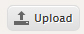
  - If the image must be uploaded click the "+" at the top to search your computer for the image
  - Once you have found and selected the image click the "Upload" button to upload the image to the web server
  - When the file is uploaded you can then select it for use in the web page.
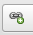
- The chain button will allow you to create a link on the page. Highlight the text or image for the link, click this button and type the web address into the form.
- When you have finished editing the message click "Submit This Content" to save the page. It will now be available for users.

