How To Guide - Creating Email Messages
The Email Broadcast System is used to send formatted messages to all users or to selected users with optional attachments.
- Go to "EMAIL SYSTEM" tab => select "Edit Email Messages".
- Click the "Add Message" button at the top or the "Add New Message" button at the bottom.
- Enter a subject line for the message.
- Type your message in the large editor box below. The editor provides a number of formatting buttons: 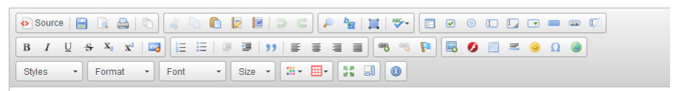
- "Paste" text, set text to "Bold" or "Italics", to chage the color of the text and the font face or size.

- The polaroid picture button will allow you to upload images to the server. Click this button,
then click "Browse Server" and then click "Upload" to copy an image from your computer
to the server. Once the file has been uploaded you can click on it and insert it into your
message.
- When you have finished editing the message click "Submit This Content" to save the message. It will now be available for sending to users.

