How To Guide - Deleting Students
You may need to delete a student who has left the school. If the student has no orders in the system:
- Go to "ADMINISTRATION" tab => select "Students".
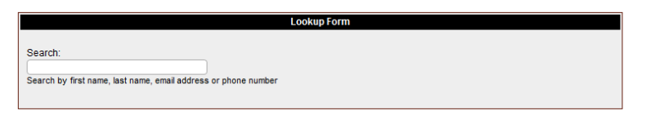
- Type the student's first or last name into the "Lookup Form".

- As you type a list of matching students will appear in a list below the entry field. You can stop typing at any time and click on a student and you will then go to the "Student Information" screen where the student will be listed with any orders they have in the system.

- From this screen you can click the "delete" icon to delete the student from the system.
If the student has "Paid" orders in the system you should not delete this student as this will affect the user account balances, revenue reports, etc. Instead you should set the student to "Inactive" so as to remove them from your reports.
- Locate the student as above.

- Click the "pencil" icon beside the student's name to edit their information and set their
Status to "Inactive".
- You may wish to repeat this process and edit the parent account to set the account status to "Inactive" as well.

