How To Guide - Editing Students
You may need to change or edit a student's information in the system to update their class, add a label note or even to change the user account the student is linked to. You can look up a student by first or last name.
- Go to "ADMINISTRATION" tab => click "Students".
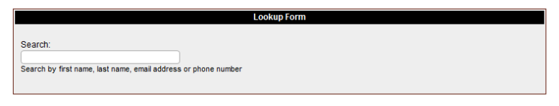
- Type the student's first or last name into the "Lookup Form".

- As you type a list of matching students will appear in a list below the entry field. You can stop typing at any time and click on a student and you will then go to the "Student Information" screen where the student will be listed with any orders they have in the system.

- From this screen you can click the "pencil" icon to edit the user account or the student to update their information.
- When editing the student you can update their class, status, user account, or name and edit any of their orders.
- After updating their account, you will return to the "Student Administration" screen where you have to option to look up another student.

