How To Guide - Entering Credits and Adjustments
Entering credits and adjustments is done by first locating the family and then accessing their account to post a transaction.
- Go to the "ADMINSTRATION" tab => select "User Accounts"
- Type the user's first or last name, email address or phone number into the "Lookup Form".
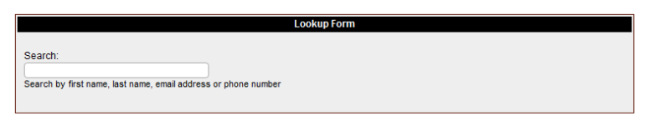

- As you type a list of matching users will appear in a list below the entry field. You can stop typing at any time and click on a user and you will then go to the "User Information" screen where the user will be listed with any students they have in the system.

- Click the "$" icon beside their name.
- Specify the transaction type, "Credit", "Credit Adjustment", "Gift", etc. The screen defaults to "Payment" when it is first displayed.
  - To add to or increase the account balance you will want to select one of the "Charges" transaction types such as "Order" or "NSF" or a "Charge Adjustment". If the user account has a negative balance (balance payable) you may be posting a "Refund".
  - To decrease an account balance, you will select one of the "Payments or Credits", typically a "Payment" to enter payments received. Other credits include "Credit Adjustments" and "Council Gifts".
- Enter the amount and type a note to explain what the transaction is for.
- Click the "Enter Transaction" button.

