How To Guide - Managing Split Families
You may need to assist split families where both parents want to access the system and place orders. The system prevents parents from adding children to the system who have already been entered so an administrator must help these families.
- First ask the second parent to register for an account so that their user account is setup with their preferred user id.
- Go to the "ADMINISTRATION" tab => click "User Accounts".
- Type the user's first or last name, email address or phone number into the "Lookup Form" to locate the second parent's account.
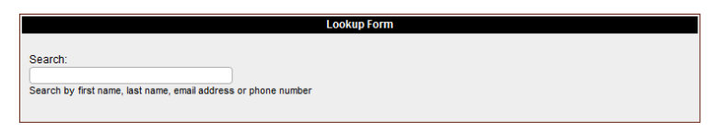

- As you type a list of matching users will appear in a list below the entry field. You can stop typing at any time and click on a user and you will then go to the "User Information" screen where the user will be listed with any students they have in the system.
- From this screen you can click the "students" icon to edit or update the students associated with this user.

- Click "Add Students" to add the children to the system. These will be duplicates of the students already linked to the first parent's account. Once you have added the students this parent will be able to place orders for the children and make payments.

