How To Guide - Sending a User Account Reminder
How to send a user their account info when they have forgotten the user id or password.
- Go to "ADMINISTRATION" => "User Accounts".
- Type the user's first or last name, email address or phone number into the "Lookup Form".
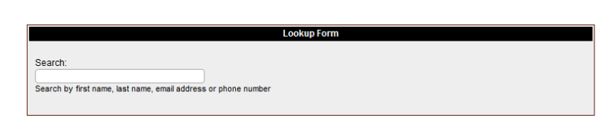
- As you type a list of matching users will appear in a list below the entry field. You can stop typing at any time and click on a user and you will then go to the "User Information" screen where the user will be listed with any students they have in the system.

- From this screen you can click the "pencil" icon to edit the user account to update the information such as email address or password. If their email address is correct you can send them their account info.

- Click on the first "email" icon to send them their account information. The second email icon will allow you to send the weekly reminder to them if they want it.

