How To Guide - Transferring Credits Between Sites
If you are using the system with multiple sites you may be required to transfer a user's credit from one site to the other. This is done by first locating the family and then accessing their account on the site where they have a credit to post a transaction.
- Go to the "ADMINSTRATION" tab => select "User Accounts"
- Type the user's first or last name, email address or phone number into the "Lookup Form".
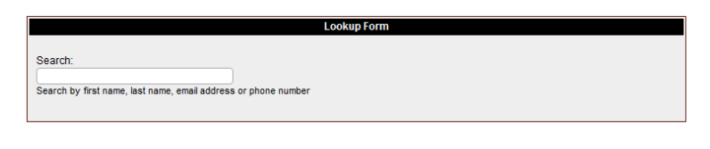
- As you type a list of matching users will appear in a list below the entry field. You can stop typing at any time and click on a user and you will then go to the "User Information" screen where the user will be listed with any students they have in the system.

- Click the "$" icon beside their name
- Enter a "Charge Adjustment" transaction.
- Enter the amount to be transferred, typically the full credit balance, and type a note to explain that the balance is being transferred to another site.
- Click the "Enter Transaction" button
You will then need to log into the other site and repeat the process, but this time post a "Credit Adjustment" for the same amount and the note should indicate that the amount is being transferred from the other site.

