How To Guide - Changing a User Password
You can look up a user by first or last name, email address or phone number.
- Go to the "ADMINISTRATION" tab => click "User Accounts".
- Type the user's first or last name, email address or phone number into the "Lookup Form".
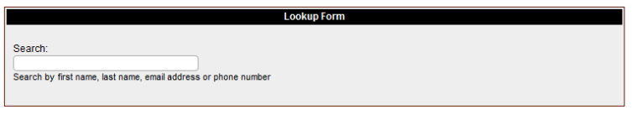
- As you type a list of matching users will appear in a list below the entry field. You can stop typing at any time and click on a user and you will then go to the "User Information" screen where the user will be listed with any students they have in the system.

- From this screen you can click the "pencil" icon to edit the user account to update the information such as email address or password.
- Type a new password into the "Password" field, typically something simple as the user will change it after they login.
- Ensure that the correct email address is in the account and then "Update" the data. You will then be returned to the "User Info" screen.

- You can click the "email" icon to send the account info to the new user.

