How To Guide - Deleting Transactions
Deleting transactions is a two-step procedure as a "Deleted Transaction" audit trail is maintained.
- Go to "ADMINSTRATION" tab => "User Accounts"
- Type the user's first or last name, email address or phone number into the "Lookup Form".
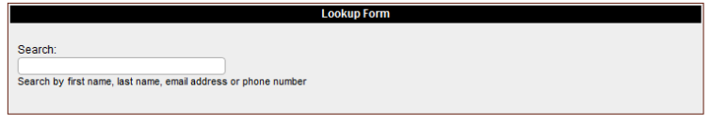
- As you type a list of matching users will appear in a list below the entry field. You can stop typing at any time and click on a user and you will then go to the "User Information" screen where the user will be listed with any students they have in the system.

- Click the "$" icon beside their name

- Find the transaction you wish to delete and click the "Delete" icon.
- On the next screen enter a reason why this transaction is being deleted. This will be visible on the "Deleted Transactions Report".
- Then click the "Delete Transaction" button to complete the process.

