How To Guide - Supplier Products and Taxes
Suppliers may charge taxes on the orders and taxes may apply to only selected items offered by a supplier. In order to provide the flexibility to tax certain items but not all tax rates are set in the supplier record but each item must be flagged to indicate if it is taxable or not.
- Go to the "ORDERS" tab => select "Suppliers" => edit supplier
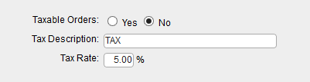
- Set tax fields accordingly
This will set the tax rate for all order for this supplier on products that are taxable.
Next you will have to edit the Supplier Products for this supplier to set the “Taxable” flag for each product. When a product is edited you must update this field.

An alternative method is to go to the Supplier Products list and click the “Edit Prices” button at the bottom of the list. The screen displayed will allow you to quickly update the taxable flag on all products for the supplier.
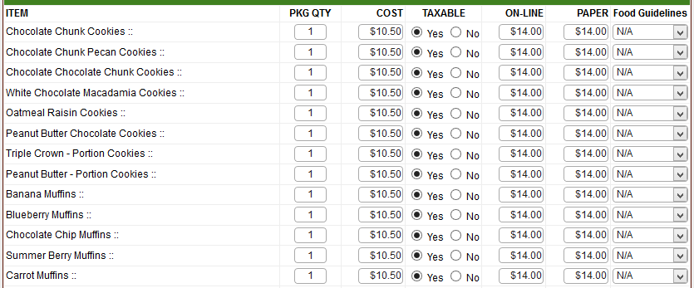
NOTE: Menu Items must be flagged as taxable as well for taxes to be calculated if menu has been built already

