How To Guide - Suspending a User Account
You may need to edit a user account to prevent the user from ordering or to even delete the account.
- Go to the "ADMINISTRATION" tab => select "User Accounts".
- Type the user's first or last name, email address or phone number into the "Lookup Form".
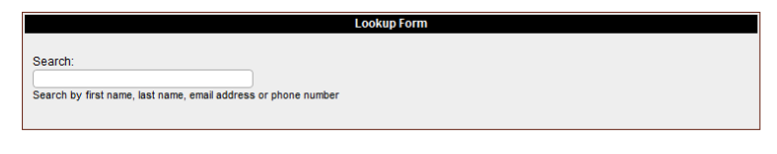
- As you type a list of matching users will appear in a list below the entry field. You can stop typing at any time and click on a user and you will then go to the "User Information" screen where the user will be listed with any students they have in the system.

- From this screen you can click the "pencil" icon to edit the user account to update the information such as email address or password.
- If you wish to prevent the user from placing any further orders change the field " User Can Place Orders" and set it to 'No' if this user cannot place orders, or set the field to 'When Balance is Zero' if they can place orders once they have paid their outstanding balance.
- If you want to prevent this user from accessing the system change their "User Status" to 'Inactive' or 'Suspended'.
- Click the "Update" button at the bottom of the form to save your changes.
- If necessary, click the pencil beside any children's names and change the status of any 'Unpaid' orders to 'Inactive' so that the food is no longer delivered to the children.

