How To Guide – Updating Menu Prices

When editing a schedule, it is possible to update all the prices in a menu in a single screen. When the “Manage Menu Items” icon is clicked there are several large buttons at the bottom of the screen.

Click on the “Update Menu Prices” button to edit the prices of every item in the current menu.
You will then be presented with a screen similar to this:
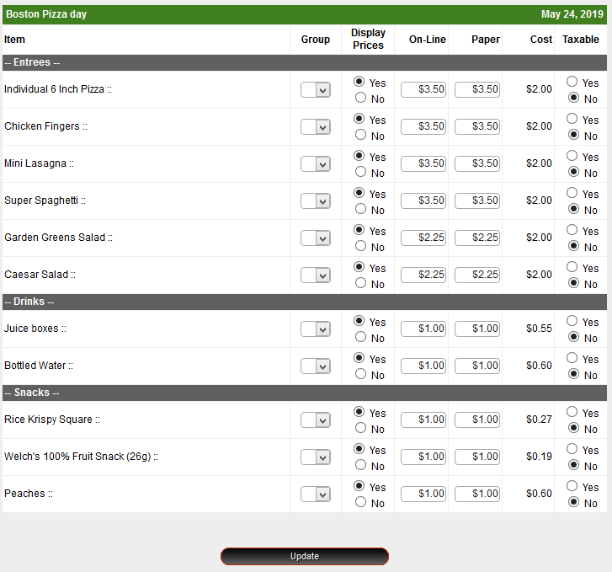
On this screen you can update “Menu Groups”, prices and the taxable item flag for each menu item.

It is possible to update the prices for all menus in the schedule by clicking the small “Update Menu Prices” button at the bottom of the screen. This will allow you to update the prices of every item in the schedule.

