How To Guide - Updating a User Account
You may need to change or edit a user account because the parent has forgotten their password and has an incorrect email address or perhaps a parent who ordered with a paper order wishes to go online and access their account. You can look up a user by first or last name, email address or phone number.
- Go to the "ADMINISTRATION" tab => "User Accounts".
- Type the user's first or last name, email address or phone number into the "Lookup Form".
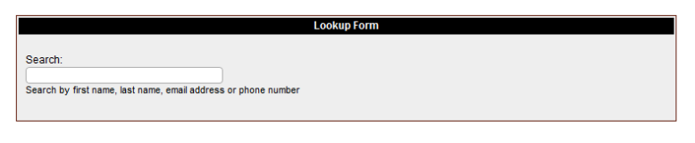
- As you type a list of matching users will appear in a list below the entry field. You can stop typing at any time and click on a user and you will then go to the "User Information" screen where the user will be listed with any students they have in the system.

- From this screen you can click the "pencil" icon to edit the user account to update the information such as email address or password.
- If a parent who ordered with a paper form previously now wishes to login you will probably want to contact them and ask what user id they would like and then edit their account to change the user id and password. Also ensure that the account has their correct email address and save your changes.
- If required, you can enter up to three email addresses for each user account so that broadcast emails and the weekly menu reminders can be sent to multiple email addresses.

- After updating their account, you will return to the "User Information" screen where you can click on the "email" icon to send them their account information.

